AUTO BELAY SAFETY COMPETENCY

I Martin Chung and/or my child/minor
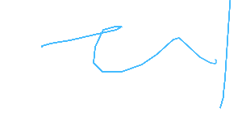
acknowledge that I/we have undertaken the Gravity Worx Safety Induction and am able to use the gym facilities unassisted, including the autobelay only (NOT the top ropes), as well as having a thorough understanding of the following;
* Gravity Worx Centre Rules
* Proper use of harness
* Proper use of karabiners (including that I must have two karabiners clipped into my harness before leaving the ground, clipping direction must be opposing)
* Proper communication
* Proper use of auto belay systems and safety "CLIMBER ABOVE" drop down Mat
* Buddy check of climbing partner prior to leaving ground on every climb
* Identification of potential hazards and how to safely move within the gym.
_____________________________ Date 6/12/2025
(Signature)

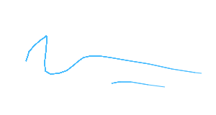
_____________________________ Andrew Tran
Trained by (Signature) (Printed)

