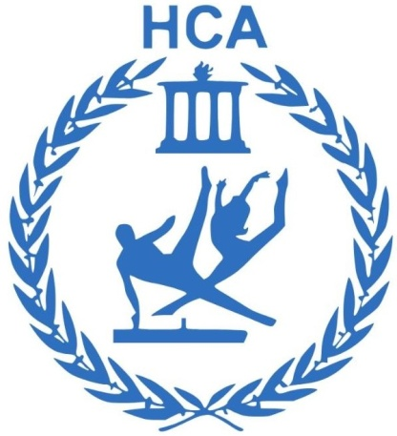 |  |  | NSA GYM  /S JIM LTD/  National Sports Academy 'Vasil Levski'  Indoor Sports Facilities, Hall 108  Studentski grad, Sofia
 |  |  |  | infonsagymnastics@gmail.com
 |  |  |  | +359 892 05 15 80
 |  |  |  | https://nsagym.com
 |  |  |  | Instagram - nsagym

DECLARATION FOR ENROLLMENT IN GYMNASTICS IN NSA GYM / S JIM LTD.
I, ##FirstName## ##LastName## , by email : ##Email## , Telephone : ##Phone## , I declare that I agree and am familiar with the conditions for conducting workouts at NSA GYM / S JIM LTD.

№ | Name and surname of the child | Child's Date of Birth
1 | Tuana | 18.5.2017 г.
2
3

THE ESSENCE OF THE SERVICES OFFERED AT NSA GYM
GROUP AND INDIVIDUAL TRAINING.

NSAGYM hosts group and individual gymnastics training for children aged 3 - 15 years. Children play sports, learn new skills, develop their motor qualities (strength, endurance, flexibility, agility and speed), during play and entertainment. Training takes place in professionally equipped gymnastics halls with equipment designed specifically for children, where boys and girls have the opportunity to learn and improve in a safe environment with the help of NSA GYM specialists. Through fun games, applied exercises and acrobatic elements, children develop both motor and social skills (teamwork, self-initiative, overcoming fears, etc.) in groups.

Training for children at NSA GYM follows a structured program developed for each activity, which is age-appropriate and basic principles for the correct acquisition of various skills by professional specialists in gymnastics. Each workout begins with a short preparatory part, in which the coaches conduct a warm-up and demonstrate specially developed complexes of general developmental exercises with and without a device. In the main part of each activity, the children are divided into small groups and go through three of the gymnastic equipment. At the end of the training, the children gather again for the final part, in which they play a game or develop one of the motor qualities (strength, endurance, flexibility, agility and speed).

In order for your child to be engaged by the coaches and to learn independence, the presence of parents in the gym is not allowed. Each parent can enter the hall and help their child change clothes in the locker room, then wait outside the hall. For children who cannot take care of themselves in the toilet and changing room, it is mandatory that the parents are nearby. For this purpose, there is a waiting area right next to the door of the hall. And when called by a coach, they need to get to the gym within 1-2 minutes.

The NSA GYM team makes every effort to ensure the safety of children in the gym and in the lobby. The responsibility for the safe entry and exit of the children from the hall lies with the parents, guardians or other adults who accompany him during the activities and undertake to comply with the internal rules. In the lobby, the children are under the supervision of the adult with whom they came.

NSA GYM workouts, depending on the age of the children, are held two or three times a week, with the ability to choose how many times a week to involve the child. The duration of classes for our youngest children (3-4 years old) is 45 minutes, and for older children over 4 years old it is 60 minutes. The training schedule of the individual groups is announced and updated on the website: https://nsagym.com/

A declaration of use of the NSA GYM service is concluded by the legal representative (parent, guardian) of a child aged 3 to 15 years, after familiarizing himself with the General Terms and Conditions, the applicable documents regarding the collection, processing and storage of personal data, the provision of mandatory information, consents and declarations regarding the legal representative of the child and about the child and after signing the NSA GYM Registration Form.

The identification of children during training and for the purposes of this contract is done only with the child's first name or other address specified by the parent/guardian, together with an add-on that is automatically generated by the NSA GYM system. Other personal data is not collected, processed or stored by NSA GYM.

AGE GROUPS
Types of groups according to age:

Group 1 (3 - 4 years)
At this age, children are ready to do their first independent activities under the NSA GYM program with our coaches. They are ready to follow instructions and learn basic gymnastic (motor) habits. They develop their sense of "I" and feel satisfaction and pride. They are able to perform basic gymnastic exercises with help and independently in light conditions, as their strength and coordination increase.
Group 2 (4 - 7 years)
Children at this age already have basic motor and mental abilities. The social aspect takes precedence over the pleasure of the results achieved, not only in training, but also in communication and making friends. The development of the main qualities; strength, flexibility, coordination is on a different level compared to children up to 3 years old. The ability to concentrate and hold attention for a longer time is an indicator of learning specific qualities in basic gymnastics and overcoming more complex exercises.
Group 3 (7 - 12 years old)
This is the age at which children become more responsible to themselves and the actions they take. Preparing for school and thinking about it further develops their desire to be successful in their actions in any field. Training goes to an advanced level. The element of learning in the form of a game is reduced. Those who have already mastered the basic qualities in gymnastics develop very quickly. The pursuit of success and achieving high results helps the coach to set high goals.
Group 4 (5 - 9 years)

These children love to be challenged, they can't wait to get stronger, to learn difficult exercises. Awareness at this age is in force and children know exactly what they want to achieve from activities.

Group 5 (9 – 15 years old)

Once they have reached a higher level of gymnastic skills, their confidence and self-esteem changes their attitude towards gymnastics. The goal of each activity for these children is to come out satisfied with the results achieved and to reduce the risk of demotivation.

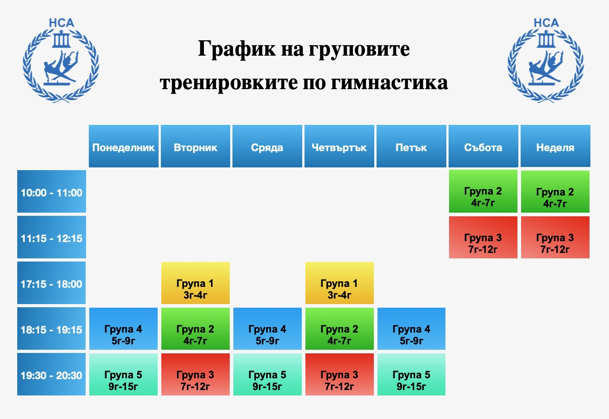

GROUP WORKOUTS

A single group visit can be booked through the NSAGYM online platform, and payment for the respective service is required.
A subscription for each group can be purchased on site in the hall. After that, it is necessary for each parent to book the prepaid workouts on the site. Without a reservation for training, children are included only if there are vacancies in the group.
When booking a place in the sports hall, the purchase of the service takes place subject to the availability of free seats for group workouts.
Before purchasing the services, a completed declaration of agreement with the general terms and conditions and the rules for visits to the NSA GYM sports hall is required.
Each child can only be included in the group that corresponds to his age.
In case of a purchased service for a single group visit or subscription, in case of an online reservation/purchase for a given group and time, the client has the right to cancel the reservation/purchase once, 2 hours before the start of the activity, otherwise the visit is considered to have taken place. In case of no-show for a booked workout, the amount is not refundable.
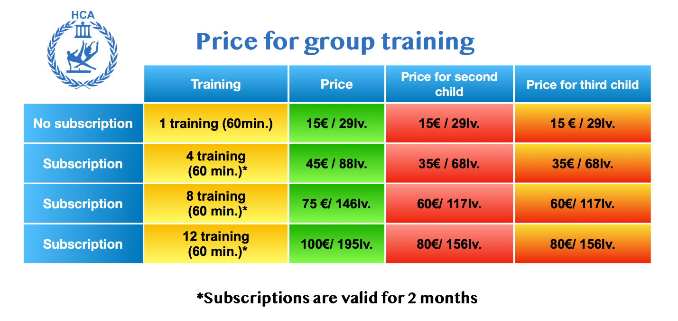
- Each subscription (except for unlimited ones) is valid for 60 days from the date of purchase!
- Unspent visits are not transferred after their expiry!
- Each subscription is used for the group for which it was purchased and when visiting another group is invalid!
- Each subscription is personal and cannot be provided and used by another person!
- The subscription with unlimited visits is valid for all groups and is valid for 30 days from the date of purchase!

INDIVIDUAL TRAINING
You can book an individual workout through the NSAGYM online platform, and payment for the respective service is required.
A subscription for individual workouts can be purchased on site in the gym. After that, it is necessary for each parent to book the days and hours for the prepaid workouts on the site. Without a reservation for training, children are included only if there are available trainers.
When booking a place in the sports hall, the purchase of the service takes place in the availability of available trainers for individual training.
Before purchasing one of the services, a completed declaration of agreement with the general terms and conditions and the rules for visiting the NSAGYM sports hall is required.
In case of a purchased service for individual training, in case of an online reservation/purchase for a given day and time, the client has the right to cancel the reservation/purchase 2 hours., before the start of the session, otherwise the visit is considered to have taken place. Cancellation is made only through the registration platform! In case of no-show for a booked workout, the amount is not refundable.

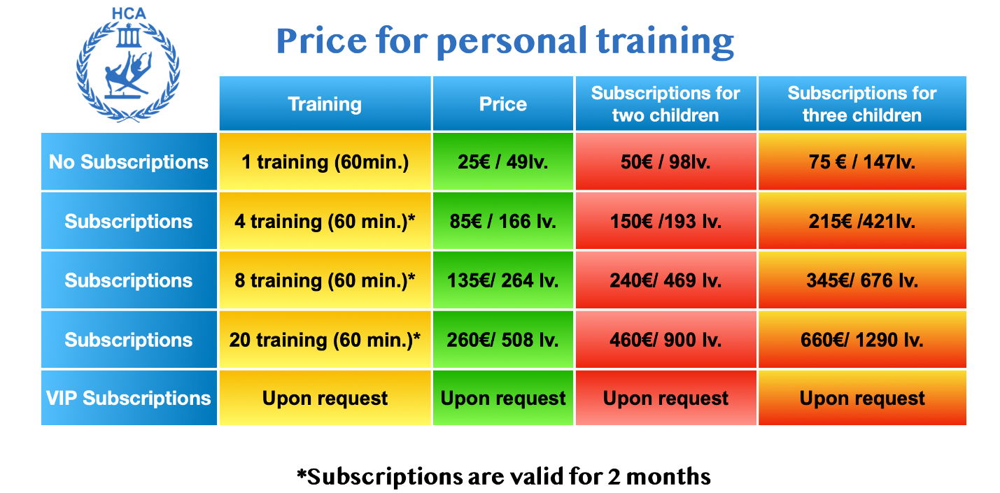
- Each subscription is valid for 60 days from the date of purchase!
- Unspent visits are not transferred after their expiry!
- Each subscription is personal and cannot be provided and used by another person!
- The subscription for two or three children can be used in cases where two or three children train in the same class with one trainer!
- The VIP Subscription is a fixed-term subscription /for the first and second school term/ with fixed desired days and hours for training!

DIFFERENTIATION OF SUBSCRIPTION PLAN, PAYMENT

NSA GYM subscriptions are valid for 60 days from the date of purchase.
Children who do not have a subscription and have not paid for a one-time visit are not allowed to train.
The term of subscriptions to NSA GYM and the activities that the children of the NSA GYM CLIENT can perform are determined by the respective group, the type of subscription and the terms and conditions in the Registration Form signed by the NSA GYM CLIENT. Subscription amounts paid are non-refundable.
In case of late payment of the due installments, NSA GYM has the right to restrict the access of the NSA GYM CLIENT and his child.
NSA GYM has the right to withhold all amounts paid under the subscription plan, provided that they are necessary to cover losses and damages caused by the NSA GYM CLIENT and/or his/her child, for which they are responsible under civil law.

SPECIAL RULES FOR USING NSA GYM SERVICES.
SAFETY AND MEDICAL REQUIREMENTS.

The CLUB and the staff are not responsible for damage, loss or theft of items or items from the Club premises (including personal transport and items located in it).

The staff of the CLUB has not undergone medical training. In case one of the clients is not sure that he is in good physical condition or in the ability to perform physical exercises, he should consult a doctor before starting to perform an exercise.
The CLUB is not responsible for injuries, injuries caused as a result of the use of the CLUB, including accidents caused by the use of devices, facilities and equipment of the CLUB.
The NSA GYM team has the right to keep children and adults with pronounced flu-like symptoms, including (but not limited to) cough, runny nose and fever, into the lobby and hall. If the child has an allergic cough, it is necessary to provide an appropriate medical certificate.
Children should be dressed in comfortable clothes that allow them to move freely. Usually they enter the gym in socks, shoes, etc. convenient workout aids to improve their balance and coordination and stay safe. It is not allowed to enter the hall with any type of shoes, jewelry, food and chewing gum.
In case a child obstructs or interrupts the conduct of the activity or is dangerous to himself, other children or team members, NSA GYM will do everything possible, together with the parents and the child, to resolve the issue. If, however, the behavior continues to interfere with the activities, the child will be asked to leave the activity temporarily or permanently. NSA GYM is not responsible for damages caused by a child to another child if the team has implemented all safety precautions and yet an incident has occurred that is beyond the control of NSA GYM employees.
If, for reasons beyond the control of NSA GYM, classes cannot be conducted in person in the gym, training continues online according to a specially adapted program.
NSA GYM has the right to deny access to NSA GYM CLIENTS and their child in case they do not present a club card and a bracelet when entering the NSA GYM facilities.
NSA GYM reserves the right to change the schedule and frequency of classes, to increase and decrease their number and type, for which it promptly informs NSA GYM CLIENTS.

RIGHTS AND OBLIGATIONS OF NSA GYM CLIENTS
The child of the NSA GYM CLIENT is entitled to use the services of NSA GYM for the period specified in the Registration Form, as of the date of the start of this subscription within the announced training schedule, in which the child of the NSA GYM CLIENT is enrolled and participates.
The NSA GYM CLIENT is obliged to make sure that his child is able and has no medical or other reasons for using the services of NSA GYM. In case of doubt about the child's ability to fully and safely participate in NSA GYM training, the NSA GYM client is obliged to consult with the coach or another representative of NSA GYM.
The NSA GYM CLIENT undertakes to take and pick up his/her child from NSA GYM personally and has no right to assign his/her subscription card, respectively the use of the facilities in the club, to third parties.
Each NSA GYM CLIENT is obliged, upon entering the hall, to provide his club card to a receptionist.
NSA GYM CLIENTS must observe hygiene in the complex and not bring food and glass bottles into the complex.

I agree to the terms and conditions and declare that I will comply with all rules and instructions given by NSA GYM / S JIM LTD.  Date: ##Date## | 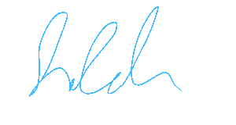  Signature:

CONSENT TO RECEIVE MARKETING COMMUNICATIONS
I agree ☐ I disagree
X
to receive from NSA GYM news, as well as promotional and marketing messages regarding the products and services offered by NSA GYM. I am aware that I can withdraw my consent to receive said communications at any time.

☒ Agree(s)
I am and do cede to NSA GYM / S JIM EOOD the right, while I, my child and all other persons entered in the declaration are located on the territory of the Center and in the process of using the services offered by the Center, the right to record, process, store, reproduce, modify and/or incorporate into audiovisual and/or photographic works my/that of my child image and/or voice, including parts thereof, to be used for advertising and/or commercial purposes by NSA GYM / S JIM LTD for the maximum period specified by law, for the whole world, without restriction of the territory, as well as the way in which they can be used, as the copyright on the created audio-visual and/or photographic works belongs to NSA GYM / S JIM LTD.
Date : 2.10.2026 г. Signature:

